Dryer Reminder

Michael Mohler

CST-451 Capstone Project Requirements Document

Grand Canyon University

Instructor: Professor Mark Reha

Revision: 1

Date: 10/24/21

**ABSTRACT**

The Dryer Reminder is a device that can pair with a phone application to tell the user when their dryer has stopped spinning. Notifications are so ingrained into people that they wish they had them for the appliances in their home. The way dryers notify people on their own isn’t enough for many. The noise alert from a dryer can be missed after the jingle has finished. The timers are not consistent either to just match it with a phone timer. A notification from a phone would easily grab any user’s attention. Stay at home spouses, the hard of hearing, and tech enthusiasts would be ready to grab this for the convenience of not missing when their dryer has finished.

It might seem hard to develop this for any kind of dryer, but all the device needs to do is check if it is shaking. Every dryer needs to move to dry the laundry out, which makes it vibrate. With research to find out what component to check for motion, it just needs some programmers for the device and phone app to get it off the ground. There should not be a need for a dedicated server, so the cost after it is finished would go to upkeep on the mobile application. The device could be sold by itself for much less than a new dryer that has the same feature installed. There are huge communities for some of the small computers they use for this. Focusing on that would allow for selling the application by itself too. There are a lot of opportunities with the Dryer Reminder project with just as many payoffs.

|  |
| --- |
| History and Signoff Sheet |

**Change Record**

|  |  |  |
| --- | --- | --- |
| **Date** | **Author** | **Revision Notes** |
| 10/24/21 | Michael M. |  |
|  |  |  |
|  |  |  |

|  |
| --- |
| **Overall Instructor Feedback/Comments** |

|  |
| --- |
| **Overall Instructor Feedback/Comments** |

**Integrated Instructor Feedback into Project Documentation**

Yes  No

**TABLE OF CONTENTS**

Functional Requirements 4

Non-Functional Requirements 5

Technical Requirements 6

Logical System Design 7

User Interface Design 8

Reports Design 9

Functional Requirements

*Refer to “User Stories.xls”*

Non-Functional Requirements

*Refer to “User Stories.xls”*

Technical Requirements

|  |  |  |  |
| --- | --- | --- | --- |
| **Technology or Tool** | **Type** | **Version or Model** | **Company or Owner** |
| Raspberry Pi | Computer | 3 B | Raspberry Pi Foundation |
| Raspberry Pi | Computer | 3 B+ | Raspberry Pi Foundation |
| Sense Hat | Board | Unspecified | Raspberry Pi Foundation |
| Thonny | IDE | 3.3.13 | Aivar Annamaa |
| Android Studio | IDE | 4.2.2 | Google, JetBrains |
| Galaxy | Smartphone | S8+ | Samsung |
| Flask | Library | 2.0.2 | Pallets |
| Fast-Android-Networking | Library | 1.0.2 | Amitshekhariitbhu |
| Python | Language | 3.7.9 | The Python Software Foundation |
| Java | Language | 7 | Oracle |

Logical System Design

System Block Diagram:

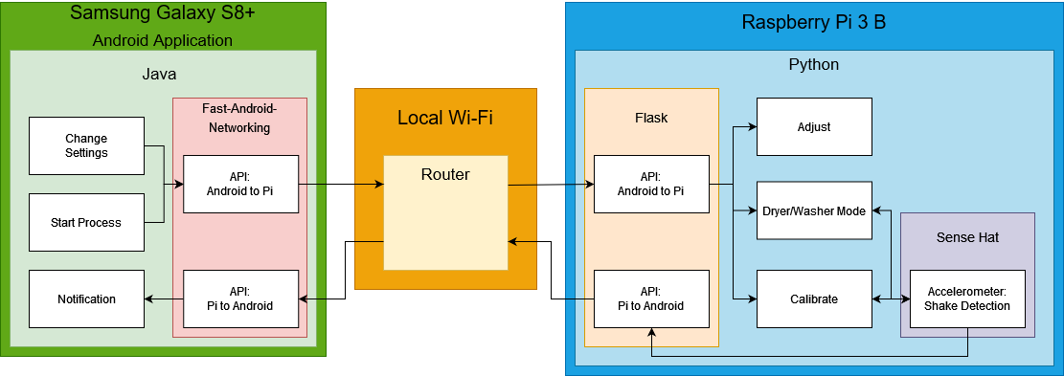

User Interface Design

Sitemap:

Adjust: Calibrate: Dryer/Washer Reminder:

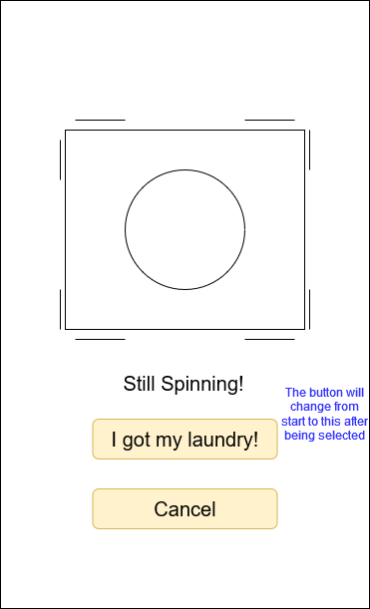

Home: Notify: Settings:

Start:

